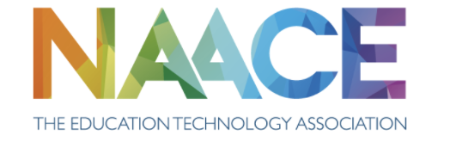

Annual General Meeting​

Monday ​5th February 2024 ​4.00 p.m. (via Teams)

- Apologies: and list of Nominated proxy:​
Andrew Murden - Proxy Joe Basketts
Bernadette Brookes – Proxy Gavin Hawkins
Deb Lyons - Proxy Gavin Hawkins
Maria Temel – Proxy Gavin Hawkins
Patrick Flynn - Proxy Gavin Hawkins

- Minutes of the previous AGM held on 24th January 2023. ​
Gavin Hawkins shared the minutes with the AGM, no questions arose.
Proposed - Phil Blackburn
Seconded – Allison Allen
All in Favour

- Matters arising​

Gavin Hawkins (GH) noted that in March 2024 it will be the 40th Anniversary of NAACE and welcomed suggestions from the group of how this could be celebrated

- Presentation of Annual Report (available at www.naace.org.uk)
​
- Report of Naace activity​

- Approval of the Annual Report and Accounts​

Gavin Hawkins shared the Annual report with the AGM including updates about the tender process and development of the ERF. Special thanks were given to Jan Harrison who supported NAACE through the tender process. Updates were given on the website development, membership database and the events NAACE has attended across the year.

Ed Fairfield also gave an update on a large-scale Research Project launched at BETT 2024. Allison Allen asked if we had yet to engage with Ofsted around this – something which the BOM will now look in to.

Phil Blackburn gave a short update on ISO9001

Donna Vaughan also shared her thoughts on the work between EANI and NAACE onboarding schools on to the ERF tool. A video is to be shared from one of the schools involved via the newsletter.

Proposer - Phil Blackburn
Seconded – Allison Allen
All in favour

- Announcement of Elections to the Board of Management​

Joe Basketts, Andrew Davis and Gavin Hawkins were elected to the board. Joe Basketts having previously been co-opted, is now a full member of the board. Gavin also welcomed Ben to the Board of Management who gave a quick update on his role.

Gavin also shared that Andrew Murden will be retiring from the board after 4 years - all members of the BOM passed on their thanks for his contributions.

- Appointment of Auditors​

- Recommendation to retain the services of Haines-Watts Ltd

Proposed - Phil Blackburn
Seconded-Jonathan Coy
All in Favour
​

- Any other business​

- Matters appropriately communicated to the Chair of the Board in advance of the meeting.
  - EdTech Review Framework – Platform Update (M Rogers)
  - Naace Research Project (E Fairfield)
  - Naace Journal Update (C Preston)

2 minor rule changes were proposed at the AGM (2.2 and 4.2) - these were approved at the AGM

Matt gave an update on the ERF, including development updates and planned roadmap for the next 12 months. Key part is around engaging new and existing schools with the ERF tool.

Gavin gave an update on the Journal in Christina’s absence.

Further discussions were held around the plan for NAACE’s 40th Anniversary celebrations

Meeting closed at 17.08

