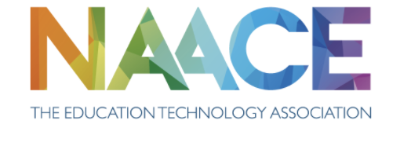

Annual General Meeting​

Monday ​5th February 2024 ​4.00 p.m. (via Teams)

- Apologies: and list of Nominated proxy:​

- Minutes of the previous AGM held on 24th January 2023. ​

- Matters arising​

- Presentation of Annual Report (available at www.naace.org.uk)
​
- Report of Naace activity​

- Approval of the Annual Report and Accounts​

- Announcement of Elections to the Board of Management​

- Appointment of Auditors​

- Recommendation to retain the services of Haines-Watts Ltd
​

- Any other business​

- Matters appropriately communicated to the Chair of the Board in advance of the meeting.
  - EdTech Review Framework – Platform Update (M Rogers)
  - Naace Research Project (E Fairfield)
  - Naace Journal Update (C Preston)

